***raa* REDLANDS ART ASSOCIATION**

GALLERY AND ART CENTER

215 E. State St <> Downtown <> Redlands CA 92373 <> 909-792-8435

**MONTHLY PROGRAM**



**Tuesday, November 22** at 7 PM

At the RAA Gallery & Art Center, 215 E. State St., downtown, Redlands

**GUEST SPEAKER: LYNDY ZOECKLER, Art Historian**

**Slide Show – Lecture – Questions & Answer**

**“Rene Lalique- Art Nouveau’s master jeweler”**

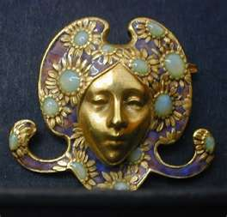

***The public is welcome to attend.*** Free to RAA members, $3.00 per guest.

Rene Lalique (1860-1945) enjoyed a long life and a double artistic career, first as a world-renowned Art Nouveau jeweler and then as a world-famous Art Deco glassmaker.  In both artistic endeavors the Parisian was highly respected for his imagination, his technical mastery of jewelry and glass, and his innovations.  He took both jewelry and glass to new areas of expression.  **Focusing on his jewelry, my talk will explore his ground breaking subject matter, his technical working methods, the women who wore his jewelry, and the devoted patrons who made his career rewarding.**  Lalique sought to unify the arts and to elevate the status of jewelry to that of painting and sculpture.  He did this by literally crafting jewelry masterpieces that were essentially miniature paintings and sculptures.  He also explored the use of unusual materials for jewelry, tirelessly experimenting with their visual possibilities.  Lalique was chiefly inspired by nature -- especially creatures and plants of the forests and woods around Paris.  He also explored the Parisian botanical gardens and employed exotic -- and even horrific -- subject matter.  Unlike other jewelers of the time, he looked also to literature, art, and music for inspiration, in particular the French Symbolists.  In his talented hands these various influences produced a new kind of beauty and works of art never seen before -- quite literally a feast for the eyes and the mind.

